Full Defects Report: JIRA Report
Defects Identified During Testing
-Credit Card field accepts alphabets
-Booking allowed without passenger name
-Expiration year accepts invalid values
-No validation for special character in name field.
-Duplicate booking possible on multiple tasks

Defect 1: 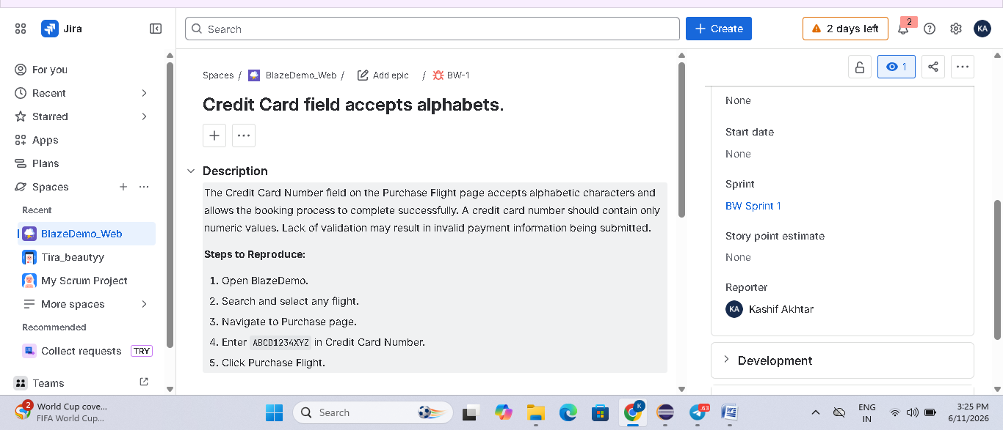
Defect 2: 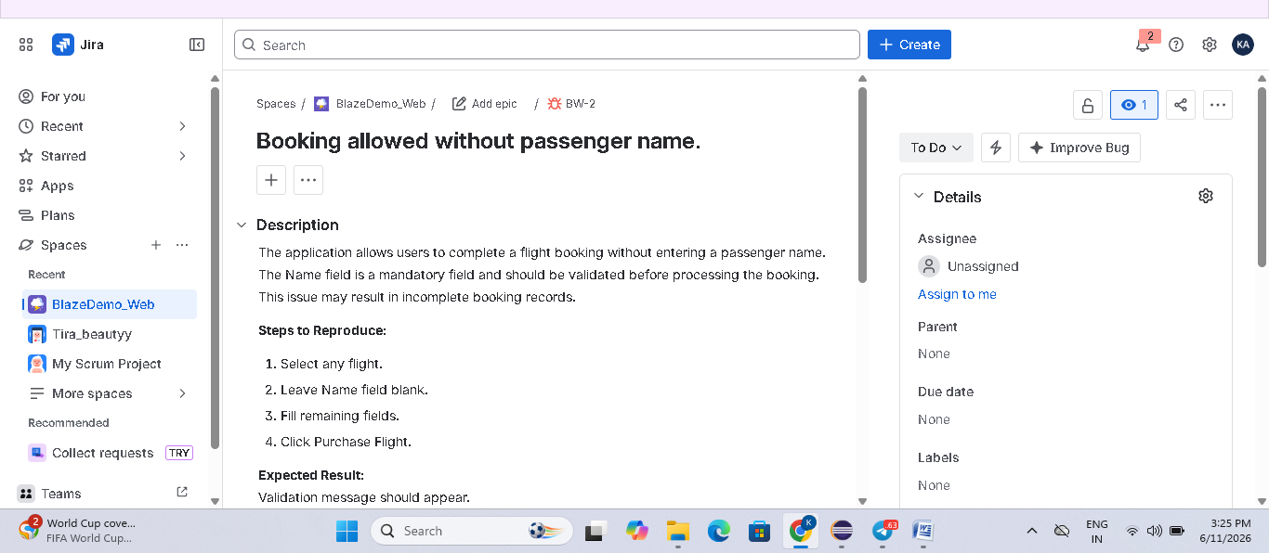
Defect 3: 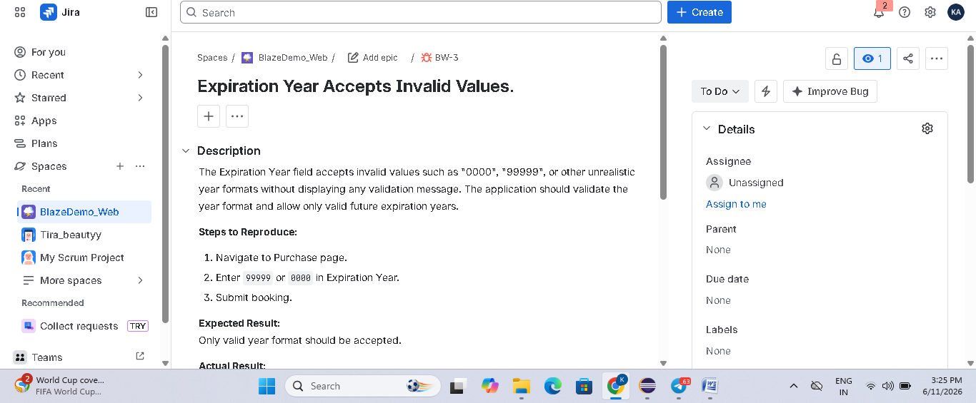
Defect 4: 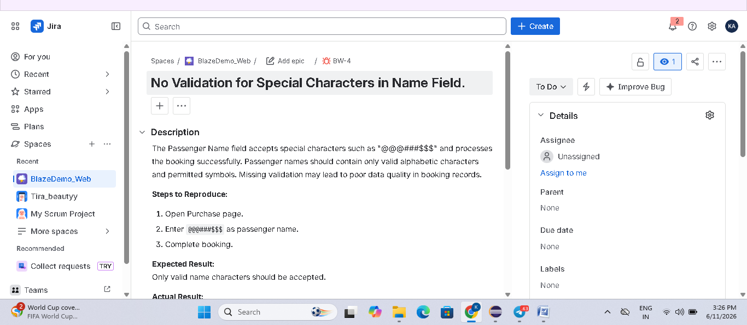
Defect 5: 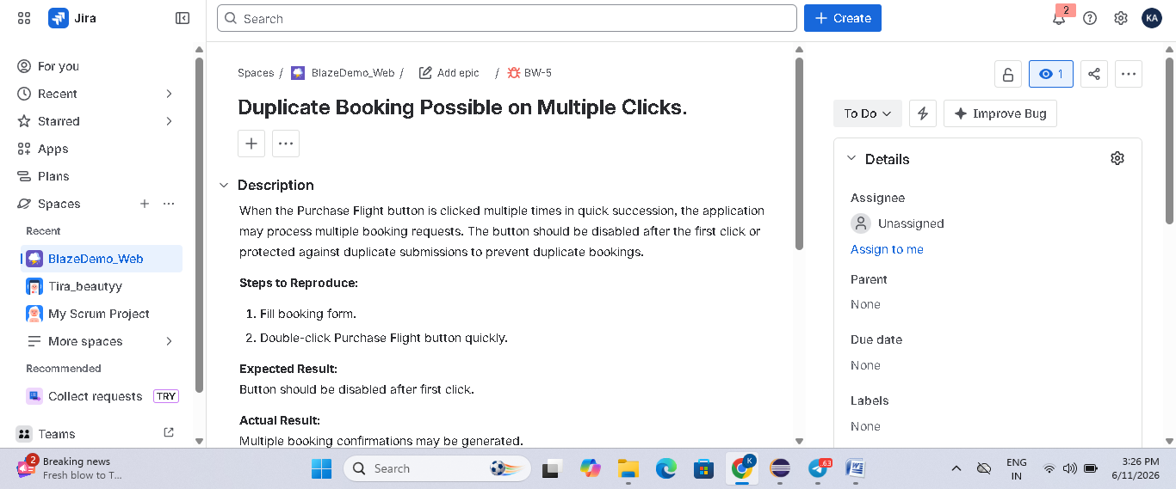
Summary of Defects: 